[**From “Human Eye” Wikipedia**](https://en.wiki2.org/wiki/Human_eye)

### Field of view

The approximate [field of view](https://en.wiki2.org/wiki/Field_of_view) of an individual human eye is 95° away from the nose, 75° downward, 60° toward the nose, and 60° upward, allowing humans to have an almost 180-degree forward-facing horizontal field of view. With eyeball rotation of about 90° (head rotation excluded, peripheral vision included), horizontal field of view is as high as 270°. About 12–15° temporal and 1.5° below the horizontal is the optic nerve or [blind spot](https://en.wiki2.org/wiki/Blind_spot_%28vision%29) which is roughly 7.5° high and 5.5° wide.

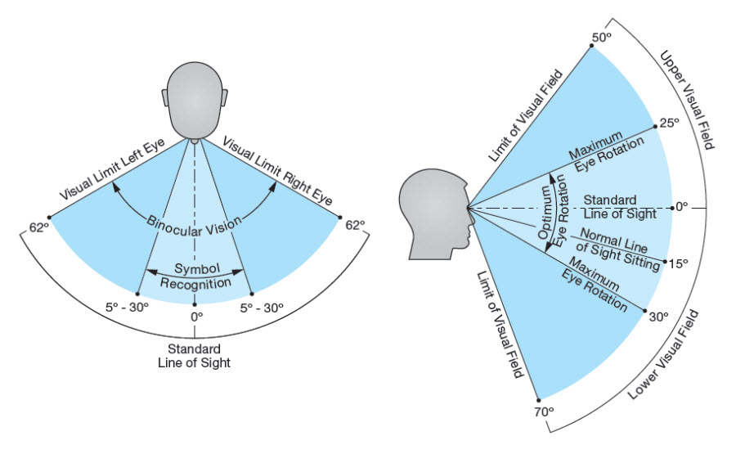

**Convex vs Concave lense**

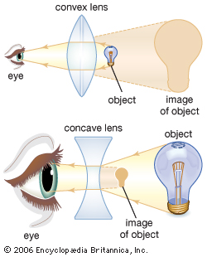

[**Nike Hindsight Concept Glasses**](http://www.gizmag.com/nike-hindsight/12148/)

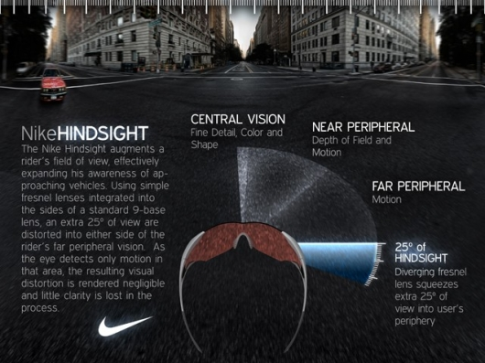

# [**Prism Glasses Expand The View For Patients With Hemianopia**](http://www.sciencedaily.com/releases/2008/05/080512163833.htm)

[**Hemianopia**](https://en.wiki2.org/wiki/Hemianopsia)

[**Corrective lenses for hemianopia**](http://www.hemianopsia.net/the-ep-lens-for-hemianopsia/)

[**Hemianopia Product Guide**](http://www.hemianopia.org/index_files/Hemianopicproductguide.htm)

[**Peli Prism**](https://en.wiki2.org/wiki/Peli_Lens) **Or also called Expansion prisms**

[**Nasa going to try out smart glasses**](http://gizmodo.com/nasa-is-going-to-try-out-smart-glasses-for-astronauts-1690993367)

[**jet pilot helmet can see through jet.**](http://gizmodo.com/the-400-000-f-35-pilot-helmet-can-see-through-the-pilo-1695445831)

[**Why it is impossible to design a perfect space suit**](http://gizmodo.com/why-its-impossible-to-design-a-perfect-spacesuit-1683283611)